1. **PURPOSE**

In an effort to go completely paperless, GT Medical signs, manages, maintains and stores Quality Management System (QMS) documentation electronically. GT Medical uses various tools to accomplish this. The purpose of this document is to establish GT Medical’s procedure when using these electronic tools, namely:

* Box.com
  + Which is an online cloud storage system. See Appendix 1 for compliance information.
* Box Sync
  + Which is a productivity tool (complimentary to Box.com) that allows to mirror data stored on Box.com to the desktop for offline access. If changes to the synced files are made locally, these changes automatically sync back up to the Box account.
* mySignatureBook application (see <http://mysignaturebook.com/>)
  + Which is an online application for electronic signature.
* editing password protection on native QMS files (Word/Excel)
  + Which is a functionality embedded with Office documents that can be used when saving Word/Excel files.

1. **SCOPE**

Additional help and guidance concerning these various tools can be found on their respective website/help community. This procedure is not meant to be exhaustive but rather provides general guidance specific to GT Medical’s QMS using these tools. Additional tools may be used by GT Medical in the future. In that case, this procedure shall be updated accordingly.

1. **REFERENCES**

* F-005A, Electronic Tool Permissions Log
* SOP-001, Quality Manual

1. **DEFINITIONS**
   1. MSB: mySignatureBook (application)
   2. ePak: An ePak (E-packet) is a package of documents that is sent/transmitted electronically to the signatory for signing. An ePak may contain one or more documents.
   3. Workflow: A path or a sequence of events an ePak follows from initiation to completion. In other words, a workflow is like a road map that an ePak follows as it moves through the signing process.
   4. Custodian: A user responsible for preparing document(s), creating ePaks, and requesting signatures on them. A RAQA Consultant currently holds a Custodian license with mySignatureBook. See [MSB’s Presentation on Custodian](https://app.box.com/s/1vmn9okdmpu5lqscxpcr8voizugdax8h).
   5. Signatory/Signer: A user who receives signature requests, and reviews and signs documents within ePaks. See [MSB’s Presentation on Signers](https://app.box.com/s/ztsyaqcor45l4k3euokhhmxqg6u5iz7f).
   6. MSB Administrator (Admin): A user who has the ability to perform administrative tasks such as invite users, manage users, reset passwords, reassign Custodians and modify application settings. The RAQA Consultant does not currently hold an Administrator license with mySignatureBook.
   7. Retention Period: Period for which an ePak is retained within MSB. By default, this value is set to 30 days however this can be configured if needed.
   8. Collaborator: A Box user who has been given access to view or modify a particular folder on an ongoing basis. If you’re a collaborator, the folder will appear when you log in to your Box account.
   9. Shared link: A unique URL generated by Box that allows the recipient to access either a specific file or folder. Shared links differ from collaborators in that they can be accessed by those who do not have Box accounts.
2. **RESPONSIBILITY**
   1. Responsibilities of a Signatory on mySignatureBook include:
      1. Reviewing and responding to ePak requests in a timely manner.
      2. Applying signature or rejecting the signature request, providing signing reasons or rejection reasons and comments where applicable.
      3. Keeping account credentials safe, never sharing password or account information with others.
      4. Changing password when a password expiration notification is received.
      5. When applicable, delegating a received ePak to an appropriate signing recipient.
   2. Responsibilities of a Custodian[1] on mySignatureBook include:
      1. Uploading documents into MSB and creating ePaks.
      2. Creating and managing Workflows.
      3. Choosing signers and reviewers for ePaks.
      4. Designating where a signer will place their signature on a document.
      5. Ensuring all requested signatures are applied to an ePak.
      6. Addressing reasons supplied by signatories that reject an ePak, making any necessary changes and re-sending an updated ePak.
      7. Downloading the ePak (document) after all signatures have been applied and storing them in the appropriate BOX repository for long term retention.
   3. Responsibilities of an Owner on Box.com and Box Sync include:
      1. Under the Box account currently held by GT Medical[2], there can only be one Owner. This person has full permissions on every folder s/he created. Currently, ownership of the QMS on Box is held by the RAQA consultant. This ownership can be transferred to GT Medical’s QA Representative if needed (see procedure at Section 6.9 – Transferring ownership of this document).
   4. Responsibilities and rights of an Editor collaborator on Box.com and Box Sync:
      1. An Editor has full read/write access to a folder. Once invited to a folder, they will be able to view, download, upload, edit, delete, copy, move, rename, generate and edit shared links, make comments, assign tasks, create tags, and invite/remove collaborators. They will not be able to delete or move root level folders.
   5. Responsibilities of a Viewer collaborator on Box.com and Box Sync include:
      1. A Viewer has full read access to a folder. Once invited to a folder, they will be able to preview, download, make comments, and generate shared links. They will not be able to add tags, invite new collaborators, edit shared links, upload, edit or delete items in the folder.
      2. A viewer cannot adjust who can access a shared link. Viewers are restricted in shared link creation in the following ways:
         1. If a shared link has not been created for a file/folder, the viewer will only be able to create a shared link with the folder owner's default shared link setting.
         2. If a shared link has already been created for the file/folder, the viewer will only be able to create a shared link with the access level currently established with the shared link (i.e. A viewer is unable to make a shared link set to "people with the link" become "people in the company").
   6. GT Medical’s Executive Representative and/or QA Representative are the only ones allowed to edit native files such as Word/Excel on the QMS. The editing password is only known by them and shall not be shared to unauthorized personnel. Other responsibilities include:
      1. Maintaining F-005A, Electronic Tool Permissions Log up to date
      2. Ensuring QMS documentation integrity
3. **PROCEDURE FOR USING BOX.COM**

* 10 GB Storage
* 250 MB file upload limit
  1. **General**

Basic Box account uses three roles:

* 10 GB Storage
* 250 MB file upload limit
* 10 GB Storage
* 250 MB file upload limit
* 10 GB Storage
* 250 MB file upload limit
* 10 GB Storage
* 250 MB file upload limit
  + Owner
  + Editor
  + Viewer
  1. **QMS Box Folder Structure**

GT Medical’s QMS structure on BOX is to be managed only by GT Medical’s Executive Management Representative and/or GT Medical’s QA Representative. The following outlines the minimum folders, other folders (i.e. misc) may be created as needed.

The Box folder is divided into a *Draft Documents (Review) folder* and *Controlled Documents and Records folder*. The Controlled Documents and Records folder has at minimum the following subfolders:

* Active QMS Documents
* Obsolete Documents
* Active Product Documentation
* Quality Records

The following Figure 1 provides an example of how these subfolders are linked together and what type of information they should contain. This information shall include, as applicable, documents of external origin that are necessary inputs to the quality management system.

Figure 1 also shows how the approved files (and redlined files if applicable) should be moved from the *Draft Documents* *(Review)* folder to either:

* The *Active QMS Documents* folder
  + If the changes concern the quality manual, a procedure or a form/log.

Or

* The *Active Product Documentation* folder
  + If the change concerns product documentation (DHF, DMR, DHR).

More information can be found at Section 9.4 – Creating and saving Quality Records.

Obsolete files are stored as per SOP-001, Quality Manual in the *Obsolete* folder. Depending on the reason behind the obsolescence, the obsolete files may be placed in these three sub-folders:

* In the *After DCN* folder
  + If the obsolescence is the result of a Document Change Notice (DCN)
* In the *Miscellaneous* folder
  + If the obsolescence is the result of any other reason.

This ensures that previous approved QMS documentation is easily retrievable in case of an audit and that previous versions are archived.

* 1. GT Medical’s Executive Representative and/or Quality Assurance (QA) Representative will protect the files under these two main folders:
* *Active QMS Documents* folder
* *Active Product Documentation* folder

with a password prior to uploading content on the shared QMS folder. This password will only be used by GT Medical’s QA representative managing the account (see Section 9). Signed copies will be saved and stored in PDF format (see Section 8).

­­­

Draft Documents (Review)

Obsolete Documents

Active  
Product Documentation

Quality Records

SOP-001

Any other draft documents (DCN, ECO, memo, SCAR, etc.)

After DCN

Miscellaneous

DHF

DMR

Complaints

DCN’s

SCARs

Memos

MR’s

PO’s

Training Sign-In-Sheets (TSS’s)

Supplier Files

[…]

Approved documents with redlined documents (if applicable) are moved either to:

- ACTIVE QMS Documents

or

- QMS RECORDS

If applicable, obsolete documents are moved here after approval of the package.

Approved Supplier List (ASL)

Current Suppliers

[…]

Old Suppliers

Document Control Index (DCI)

Approved product documentation is moved here

Active QMS Documents

SOP-001, Quality Manual

…SOP-XXX

Contains

Contains

Contains

Contains

Contains

Per year

Per date

Per SCAR#

Per Memo#

Per MR date

Per PO #

Per date

Per supplier’s name

Per date

Per date

[…]

Controlled Documents and Records

…SOP-XXX

Figure 1: GT Medical’s QMS structure on BOX

* 1. **Managing Collaborators**
     1. Box Permissions
        1. GT Medical’s Executive Representative and/or QA Representative will have ownership of the QMS Box folder so that they can manage collaborators. This will give them the ability to add, edit or delete collaborators in the account.
        2. Box’s collaboration system works at the parent folder level. Collaborators have the same access level throughout a particular folder structure. For example, an editor in a parent-level folder will also be an editor in all the subfolders. GT Medical’s Executive Representative and/or QA Representative will invite contacts to join one or more of GT Medical’s folders as collaborators and define the access permissions they see fit.
        3. GT Medical’s Executive Representative and/or QA Representative will invite someone into a folder as a collaborator only if this person is working with GT Medical on an ongoing basis, and they need persistent access to the QMS content. By default, all GT Medical personnel requiring day-to-day access to the QMS will be granted the Editor role at the GT Medical folder level (highest level) so that they can have access to the five minimum subfolders contained in it (see Figure 1) and they can create quality records.
        4. The Box permissions for GT Medical are defined and maintained in F-005A, Electronic Tool Permissions Log. This log will contain:
* The title, name and email address of the owner
* The title, name and email address of the collaborator(s), if they are Editor or Viewer and at which folder level their permission is granted.
  + - 1. To invite collaborators to a folder, GT Medical’s Executive Representative and/or QA Representative will need to click on the "Invite People" box on the sidebar of the folder (see Figure 2). A pop-up window will appear where they will be able to enter the email addresses[3] of the individuals to add.
      2. Folder owner has a suite of sophisticated settings available. These properties control how the collaborators view and manage the files in the folder. To access these properties:
* Mouse over the desired folder and click the drop-down arrow. Mouse over Properties.
* A pop-up window will appear in which you can adjust the folder settings for shared links, user privileges, commenting and more.

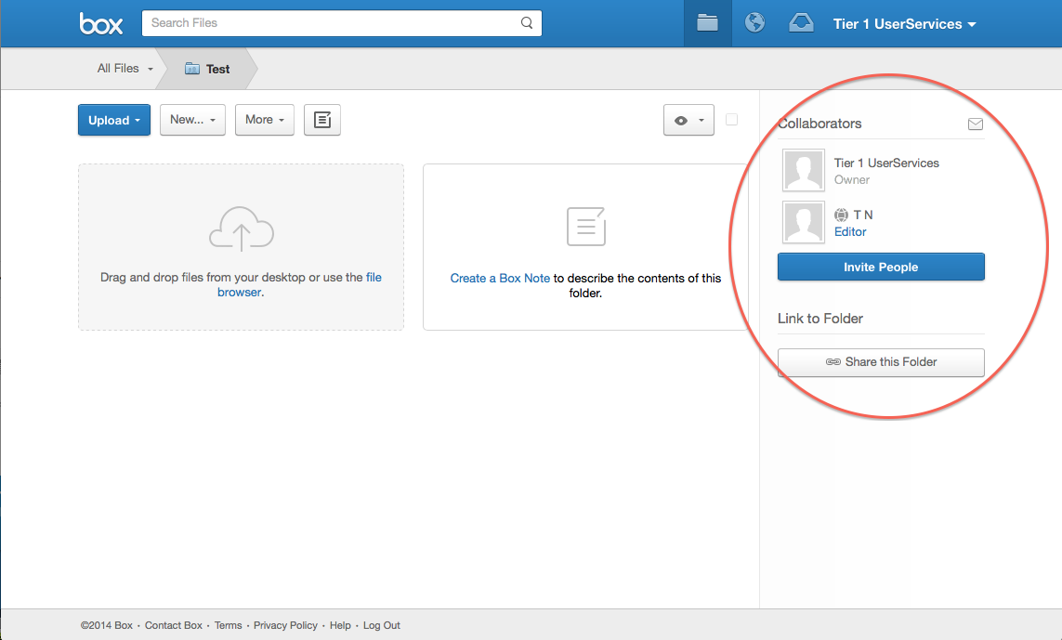

Figure 2: How to invite collaborators

* + 1. Once all collaborators have been entered, click 'Ok,' and emails will be triggered to those contacts notifying them of your invitation (see Figure 3). Once they log into their Box account, they will be able to accept or reject your invitation to collaborate on that folder.

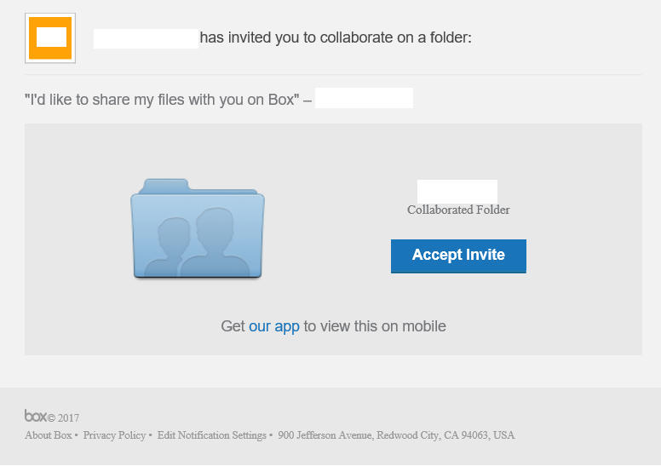

Figure 3: Email invitation

* + 1. When collaborators are invited to a folder, the folder icon will change from manila yellow to blue. All collaborative folders will automatically appear at the top of the files list within the collaborator’s account.
    2. GT Medical’s Executive Representative and/or QA Representative will invite someone into a folder as a collaborator only if this person is working with GT Medical on an ongoing basis, and they need persistent access to the QMS content. Otherwise, quick, read-only access will be granted by sending the person(s) a shared link to a folder or file. The recipient can continue to reference that link for the most up-to-date version of the content.
  1. **Logging in to your BOX account**
     1. Go to app.box.com/login
     2. Enter your email/username and password, and then click Sign In (see Figure 4).

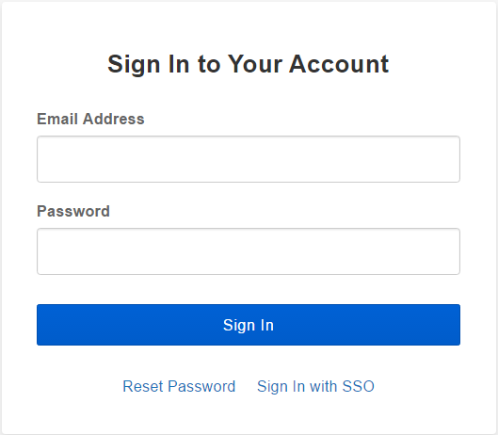

Figure 4: Box Log In

* + 1. If you forgot your password, just click the [Reset Password](https://app.box.com/login/reset?redirect_url=https%3A%2F%2Fapp.box.com%2Ffiles%2F0%2Ff%2F5537845669%2FOthers) link.
  1. **Creating a new folder[4]**
     1. Click the New button and select New Folder.
     2. In the pop-up window that appears, enter the folder name. To create a folder where you’ll work with others, pick Invite People to Upload or Download Files (see Figure 5). Otherwise, choose to keep it private.

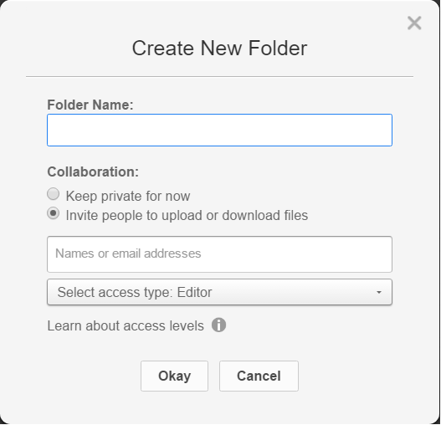

Figure 5: New Folder pop-up window

* + 1. If you need folders inside the first one to create subfolders, just click the top-level folder to open it, and repeat the steps above.
  1. **Uploading Files[5]**

If you're accessing Box from your web browser, you can use one of two methods to upload files and folders:

* Drag and Drop
  + Drag files from your desktop to the files page in Box. Your files will be uploaded and will appear in the folder where you dropped them.
* File Browser
  + There are two options to upload files via the File Browser: Use Upload Files when you only have a few to get to the cloud, and Upload Folders when there’s many.
    1. Adding Files via Upload Files
       1. Navigate to the folder where you want to send your files.
       2. Click the Upload button and then choose Upload Files.
       3. A pop-up window will appear, allowing you to select the specific file(s) you want to upload from your computer.
       4. Select the specific file(s) and click the Open button.
    2. Adding Files via Upload Folders
       1. Navigate to the folder where you want to send your files.
       2. Click the Upload button and then Upload Folders.
       3. A pop-up window will appear which allows you to browse your computer to upload folders.
       4. Once you’ve added the files or folders you need, click OK to get them up to Box.
  1. **Navigating your account** 
     1. There’s three shortcuts at your disposal to easily access your files: the Search tool, Jump to Folder and the Updates view.

* + 1. Search
       1. If you’re looking for a certain file – or even a certain word or phrase within a file – go to the Search tool. Enter your query into the search bar at the top of your page. Box will search the titles of your files and folders as well as the body of your documents. If you receive too many results, simply apply some filters. You can sort by folder, file type, date, content type, and owner (see Figure 6).

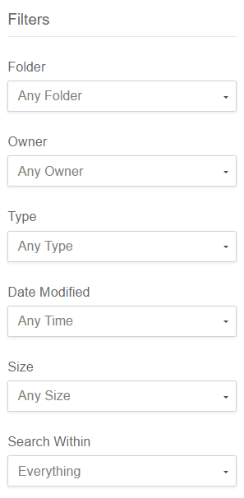

Figure 6: Filters that can be applied to help in your research

* + 1. Jump to Folder
       1. If you want to get to a folder quickly, use the Jump to Folder tool. Simply click the dropdown menu in the upper left corner to access your entire folder structure and be taken directly there.
    2. Updates
       1. On this page, you’ll see what files and folder have been recently updated in your Box account. You can click right into the file or simply view the history – including comments, tasks, versioning and more. To view recent updates, click the Globe Icon in the blue menu bar. Additionally, you can filter the results by the type of update made. To sort by action type, hover over All and select the filter you’d like to apply.

* 1. **Transferring ownership**
     1. There are two ways to change or transfer folder ownership to another collaborator. Note that to change or transfer folder ownership, you must be the owner of the folder.
        1. First method
           1. Click on the folder you own.
           2. You will see a list of Collaborators in the right pane. If you are the owner, you will notice that you are designated as the "Owner" for this folder and it will be displayed underneath your name.
           3. Click on the collaborators Role (access level).
           4. A drop-down list of all the different Roles (access levels) will be displayed. Click on "Owner".

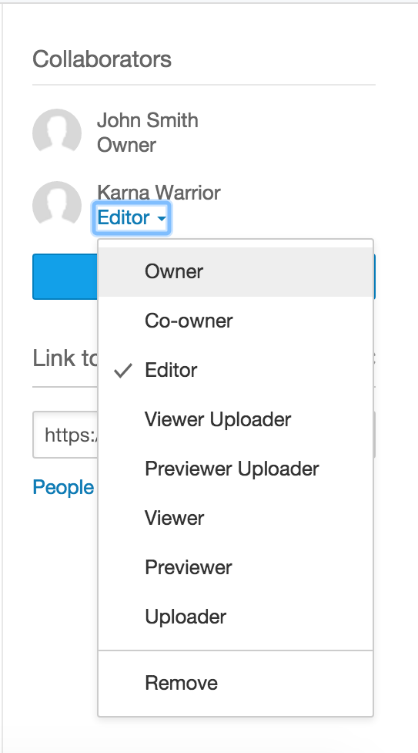

Figure 7: How to switch ownership – Method 1

* + - * 1. A pop up message will be displayed confirming your action and letting you know the implications of this action. To confirm the change, click “Okay".

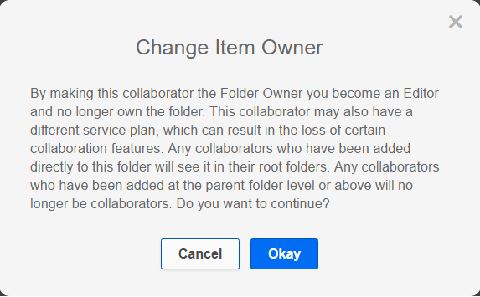

Figure 8: Warning displayed prior to changing ownership of a folder

* + - 1. Second method
         1. Click on the folder you own.
         2. You will see a list of Collaborators in the right pane. If you are the owner, you will notice that you are designated as the "Owner" for this folder.
         3. Click the collaborator's name to view all the collaborators in this folder.
         4. Under Permissions, Click the role (access level) and a drop-down will be displayed. Click on "Owner".

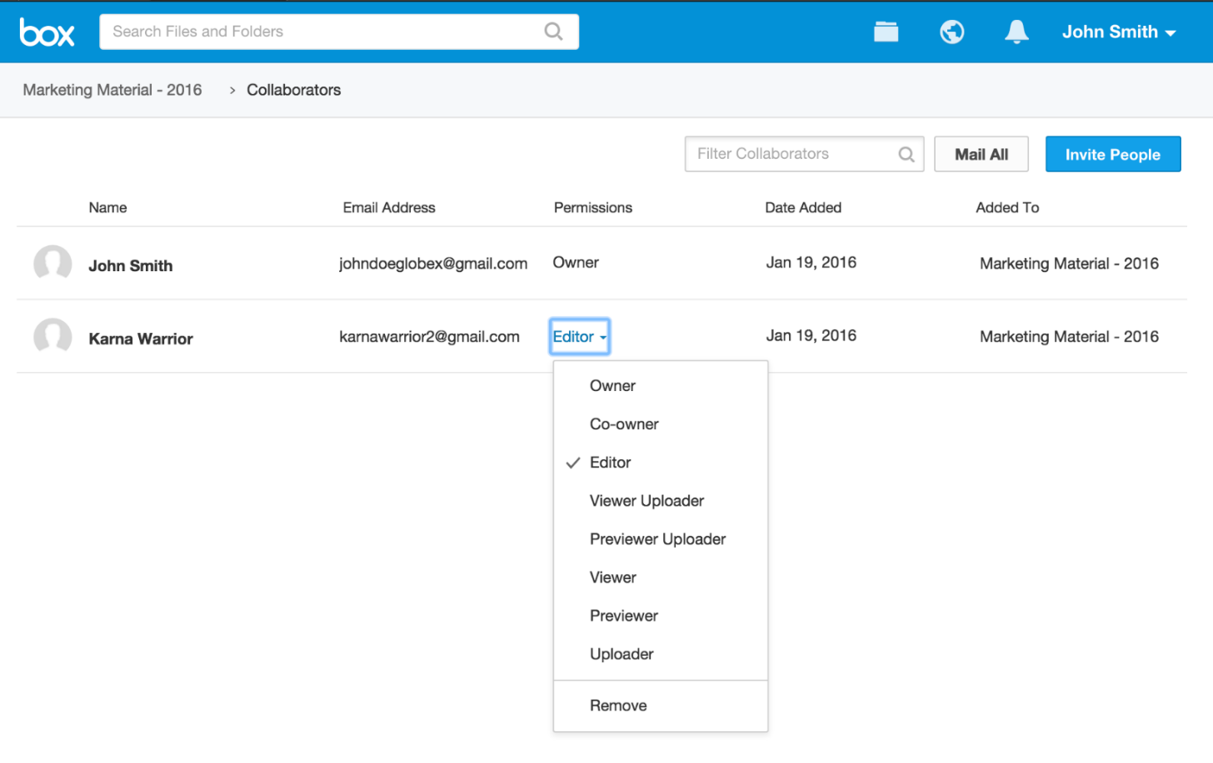

Figure 9: How to switch ownership – Method 2

* + - * 1. A pop up will be displayed confirming your action and letting you know the implications of this action (see Figure 8). To confirm the change, click “Okay”.
      1. Once completed, the collaborator you designate will be the new "Owner" of the folder and your access level will be downgraded to "Editor". The contents of the folder will no longer count against your account's storage allowance.
      2. If you are transferring a private (yellow) folder, you will first need to invite the user to this folder before you can you transfer ownership.
      3. Large folders (containing 10k files or more) may cause the transfer to time out. If you experience any issues, submit a support case so Box can assist with the transfer.

1. **PROCEDURE FOR USING BOX SYNC**
   1. **General**

Box Sync is a productivity tool that allows you to mirror data stored on Box.com to your desktop for offline access. If you make changes to your synced files locally, these changes automatically sync back up to your Box account.

* 1. **Installing Box Sync**
     1. Navigate to the "Get Box Sync" option by clicking on your name in the upper right corner of your Box account. Alternately, you can download Box Sync [here](https://www.box.com/box-for-devices/).

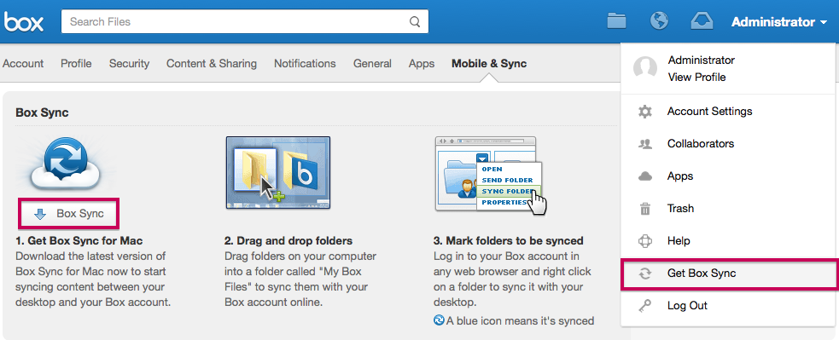

Figure 10: How to install Box Sync

* + 1. Once Box Sync is installed, you can start syncing content from Box.com to your computer by doing the following:
       1. Add files and folders to the Box Sync folder on your computer. These additions will automatically be uploaded/synced with your account on Box.com.
       2. Navigate to your Box.com account and select the folders you want to sync by following the below steps. Please note that you must have Editor Access or higher to use Box Sync on a folder.
          1. Right click on the file you’d like to sync to your computer.
          2. Select "Sync Folder to Computer" (see Figure 11).
          3. Click the Sync Folder button to begin syncing to your computer.
          4. You should see a blue icon with white arrows appear beside the folder to designate it as a folder that’s syncing back and forth to your Box Sync folder.

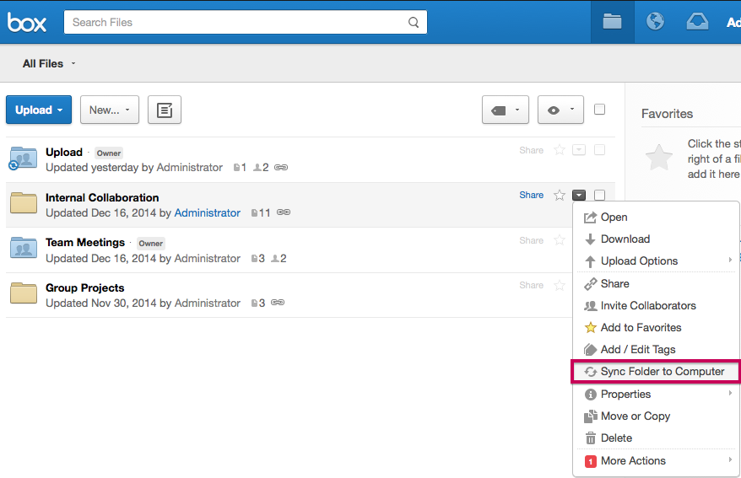

Figure 11: How to sync folders to computer

* 1. **Using Box Sync**
     1. Once you’ve chosen the files that you want to sync back and forth between Box.com and your local computer, you can edit files either from your Box Sync folder or on Box.com. When you make a change to a file that’s located in your Box Sync folder, that change will also be reflected on Box.
  2. **Additional resources**
     + 1. If further guidance is needed on basic activities for the proper usage of Box Sync, the following procedures can be followed[6]:

Table 1: Other resources for Box Sync

|  |  |
| --- | --- |
| **Activities required for the proper usage of Box Sync** | **Link to the procedure** |
| Installing/Uninstalling Box Sync | <https://community.box.com/t5/Box-Sync/Installing-Uninstalling-Box-Sync/ta-p/85> |
| Marking Folders for Sync | <https://community.box.com/t5/Box-Sync/Marking-Folders-for-Sync/ta-p/699> |
| Modifying the location of the Box Sync folder | <https://community.box.com/t5/Box-Sync/Modifying-the-Location-of-the-Box-Sync-Folder/ta-p/90> |
| Deleting Synced Folders | <https://community.box.com/t5/Box-Sync/Deleting-Synced-Folders/ta-p/88> |
| Errors Syncing Files | <https://community.box.com/t5/Box-Sync/Errors-Syncing-Files/ta-p/82> |
| Which File Types Are Ignored Or Blocked In Box Sync? | <https://community.box.com/t5/Box-Sync/Which-File-Types-Are-Ignored-Or-Blocked-In-Box-Sync/ta-p/117> |
| File Version Conflicts | <https://community.box.com/t5/Box-Sync/File-Version-Conflicts/ta-p/129> |

1. **PROCEDURE FOR USING MYSIGNATUREBOOK**
   1. **General**

mySignatureBook (MSB) is a cloud-based digital workflow and signing solution from Taigle. A RAQA Consultant manages GT Medical’s existing document signing process with this easy, customizable, auditable, regulatory compliant and highly secure platform. MSB meets or exceeds each of the legal and regulatory requirements governing electronic and digital signatures in life sciences, including FDA 21 CFR 11 and FIPS 142 regulations. See [MSB’s Certificate of Compliance for 21 CFR Part 11](https://app.box.com/s/plc9p7sn1zgvbdjymktl7u1g95enidf6).

Additionally, MSB also meets requirements for creating digitally signed electronic records for FDA (Food and Drug Administration), EMA (European Medicine Agency) and other regulatory agency submissions. The adoption of Safe Bio Pharma seal, PKI based user authentication and assimilation of best industry practices ensures that GT Medical can transact their business in a faster, safer and more efficient manner.

* 1. **Set up your account and sign your first ePak**
     1. Please follow the step-by-step guide ([mySignatureBook 3.7 Help Guide](https://app.box.com/s/uzah805xtn5xiczvk858fda1dvelr602)) carefully to properly set up your account on MySignatureBook and sign your first ePak.
  2. **mySignatureBook Permissions**
     1. The mySignatureBook permissions for GT Medical are defined and maintained in F-005A, Electronic Tool Permissions Log. This log will contain:
* The title, name and email address of the Custodian(s)
* The title, name and email address of the Signatories.
  1. **Saving and storing signed copies in PDF**
     1. Once an ePak is signed by all signatories, the ePak Custodian (namely GT Medical’s QA representative) will receive an email notification. GT Medical’s QA representative will save both signed copies provided by mySignatureBook (original and with audit trail) in the appropriate QMS folder(s).
     2. Native files (Word/Excel) will be kept in the same QMS folder as the signed copies in case a revision is needed in the future. See next section for the procedure on how to appropriately save native files under the QMS.

1. **PROCEDURE FOR EDITING PROTECTION OF QMS DOCUMENTATION AND CREATING QMS RECORDS**

The following presents a method for applying an editing password to the native files (Word/Excel) under the QMS documentation to prevent modifications from unauthorized personnel. The native files will be in read-only for everyone opening them, unless a password is provided. Other methods are acceptable (within the Microsoft products) if password protection is applied.

The password will be known by GT Medical’s Executive Management Representative and/or QA Representative only.

* 1. **Protecting native files within the QMS**
     1. Make sure the native document to which you want to add an editing password is open and click the “File” tab. On the backstage screen, click “Save As” in the list of items on the left.

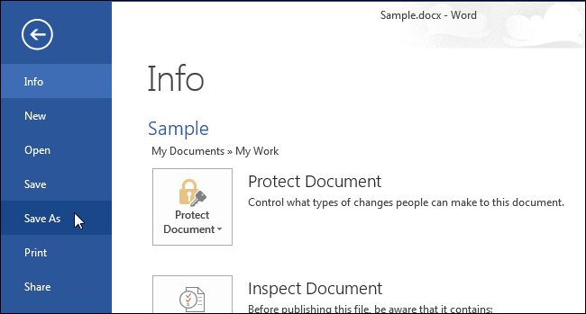

Figure 12: How to protect a document from editing

* + 1. Select a folder where you want to save the password protected document (e.g. in the *ACTIVE QMS Documents* folder).
    2. Then, click “Tools” next to the “Save” button and select “General Options” from the drop-down menu.

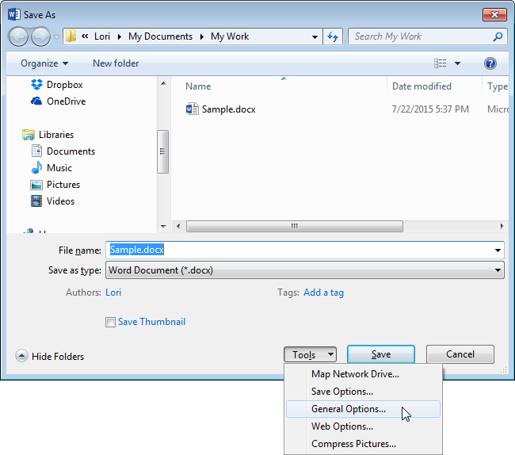

Figure 13: How to protect a document from editing *(Cont’d)*

* + 1. On the “General Options” dialog box, enter a password into the “Password to modify” edit box, select ‘Read-only recommended’ and click “OK”.

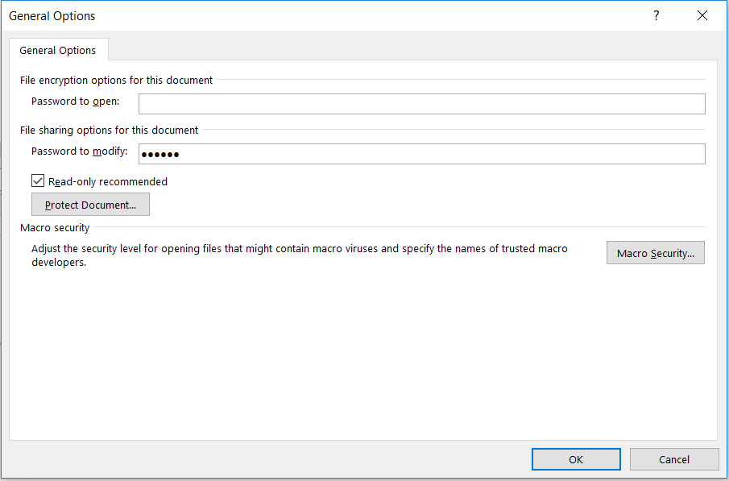

Figure 14: Password to modify

* + 1. On the “Confirm Password” dialog box that displays, enter the password again in the “Reenter password to modify” edit box and click “OK”.

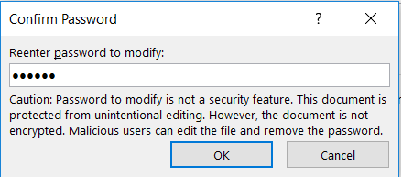

Figure 15: Confirm password dialog box

* + 1. Click “Save” to save the document with the password. The next time you open the documents, Word/Excel will ask you for the password before opening the document.

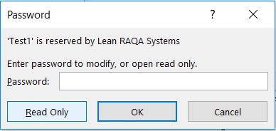

Figure 16: Enter password prompted when opening the document

* + 1. Personnel without the permissions (password) will be able to open the document in ‘Read Only’ mode. If they would like to create a record (e.g. when completing a form), they will only be able to re-save the document under another name (which should be the name of the record). They will not be able to alter an approved SOP, form, etc. Personnel with the permissions (password) as per F-005A, Electronic Tool Permissions Log will be able to enter the password and directly edit the document.
  1. **Remove/Change password**
     1. If you want to remove the password from your Word/Excel document, open the document, access either the “General Options” dialog box as described above and delete the password. Then, save the document again.
     2. If you want to change the password from your Word/Excel document, open the document, access either the “General Options” dialog box as described above and change the password. Then, save the document again.
  2. **Permissions for the editing password**
     1. The native file editing permissions for GT Medical are defined and maintained in F-005A, Electronic Tool Permissions Log. This log will contain:
* The title, name and email address of the person(s) allowed to Edit
* The title, name and email address of the person(s) allowed on Read-Only.
  1. **Creating and saving Quality Records**
     1. To create a quality record from a form/log (Word or Excel), go to the *ACTIVE QMS documents* folder to retrieve the appropriate form/log template, open it in ‘Read only’ mode (i.e., without providing a password) and re-save it under the *DRAFT documents* folder.

Important:

* Do not re-save the record under the *ACTIVE QMS documents* folder as this folder is dedicated to the approved SOP’s and forms/logs only.
* Respect the established nomenclature for the name of the records, e.g. per date/year (TSS-01_17-01-2017) or per document number (ECO-001, etc.). GT Medical’s QA Representative should make sure the naming convention for the Quality records remains consistent prior to approving/signing a document.
  + 1. Once you are done with the form/log, route the package for electronic signature using mySignatureBook, as described in Section 8.
    2. Once the ePak is signed, retrieve the two signed copies (original and with audit trail) from mySignatureBook. Place them into the appropriate *Quality RECORDS* folder, along with the native final files, i.e., moved them from the *DRAFT documents* folder to the appropriate *Quality RECORDS* folder.

1. **DOCUMENT HISTORY**

|  |  |
| --- | --- |
| Functional Area | Signature & Date |
| Operations |  |
| Quality |  |
| Regulatory |  |

|  |  |  |
| --- | --- | --- |
| **REVISION HISTORY** | | |
| Rev. # | Released Date  (YYYY-MM-DD) | Author |
| 1 | 2018-05-14 | Michelle Lott |
| 2 | 2018-11-26 | Raines DeMint |

**APPENDIX 1 – Standards complied by Box[7]**

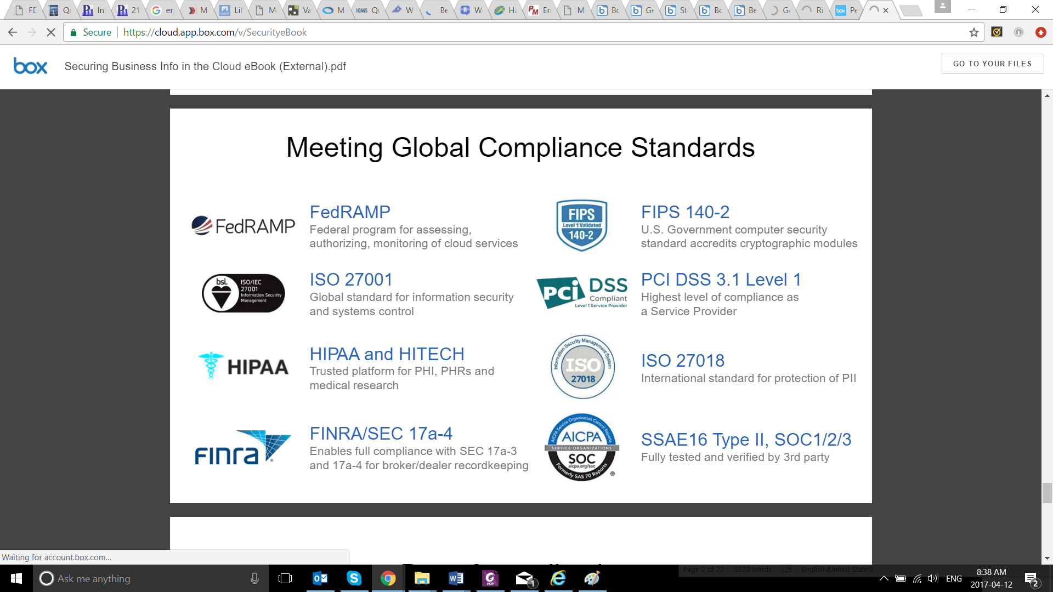

1. A RAQA consultant maintains a Custodian license for mySignatureBook (paid annually) compliant with 21 CFR Part 11..
2. GT Medical currently owns an Individual (free) plan with Box.
3. Note: This must be the same email address the collaborators have used to register for their Box accounts. GT Medical’s Executive Representative and/or QA Representative needs to verify this before proceeding. The email address must be updated accordingly in F-005A, Electronic Tool Permissions Log. If a user does not yet have a Box account, they will receive an email inviting them to sign up for a free account. Once they sign up, they will have immediate access to the collaborative folder.
4. Note that new folders need follow the QMS structure define in the previous section. Only GT Medical’s Executive Management Representative or QA Representative should modify the higher structure.
5. Note that for the free Box accounts, the total storage is 10 GB and the maximum file size is 5 GB.
6. Extracted from <https://community.box.com/t5/Box-Sync/tkb-p/BoxSync>
7. Extracted from <https://cloud.app.box.com/v/SecurityeBook>